DATE: 24.01.2020
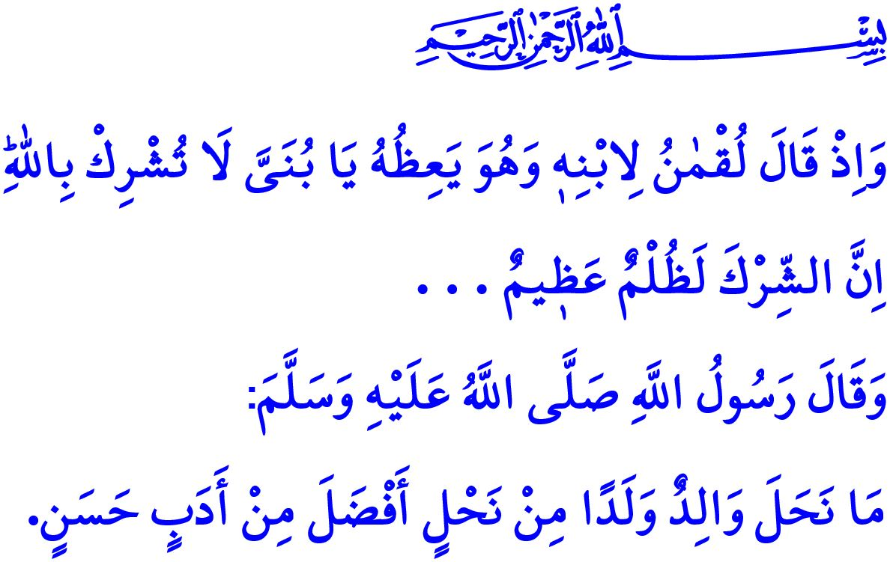
TO BE A RESPONSIBLE FATHER
Honorable Muslims!
Being a family is one of the greatest blessings granted for human by Allah (swt). This is so because family means trust, shelter, and refuge. It refers to joining hands all together to foster the good and prevent the evil. It is also the most important institution that prepares human for the future. The first education ever is given within family. Within family is formed the personality. Before everyone else, from parents are taught love, respect, and honesty.
Important duties fall upon the father in family as well as the mother. A father’s responsibility is not limited to the financial satisfaction of the family's material needs only. It is the primary responsibility of all fathers to rear children who are aware of the significance of mercy, equipped with good morals and values. In the hadith I recited as I began the khutbah, Prophet Muhammad (saw) says, “No father can leave a better heritage to his children than good manners.”
Dear Believers!
To be a father means to strive that his child is honored with iman, like Prophet Nuh. It is to make every effort so that the child could be happy in this world and in the Hereafter. Prophet Nuh called out to his son, who refused to get aboard the ship to tawhid, with his final hope, “...O my son, come aboard with us and be not with the disbelievers.”
Dear Muslims!
To be a father means to be in a state of constant supplication like Prophet Ibrahim. It is to seek refuge with Allah (swt) to be an obedient servant of His. It is to pray earnestly to Him (swt) for good children. In this respect, Prophet Ibrahim prayed to Allah (swt) as, “Our Lord! Make us Muslims in submission to You and from our descendants a Muslim nation in submission to You. And show us our rites and accept our repentance. Indeed, You are the Accepting of repentance, the Merciful.” “O Allah! Make me an establisher of prayer, and many from my descendants. O Allah, accept my supplication.”
Dear Believers!
To be a father means to preserve one's perseverance in the face of hardships, like Prophet Yaqub. It is to bear the tests and trials of the world, however heavy they may be, with patience and reliance on Allah. It is to continuously instill love, mercy, justice, and compassion in one's children. It is to warn them when they fail, but not ever give up hope in them. Prophet Yaqub said to his children who, out of jealousy, threw their brother Yusuf in a well, “...Rather, your souls have enticed you to something, so patience is most fitting. And Allah is the one sought for help against that which you describe.”
Dear Muslims!
To be a father means to give advice to one's child in a compassionate manner, like Luqman. It is to teach them what is right and what is wrong, as well as what is haram and what is halal. Luqman advised his child so finely, “O my son, do not associate anything with Allah. Indeed, association with Him is great injustice.” “O my son, establish prayer, enjoin what is right, forbid what is wrong, and be patient over what befalls you.” “And do not turn your cheek in contempt toward people and do not walk through the earth exultantly. Indeed, Allah does not like anyone self-deluded and boastful.” “And be moderate in your pace and lower your voice...”
Dear Muslims!
To be a father means to follow the Sunnah of Prophet Muhammad (saw), who was sent as mercy to the worlds. He (saw) was an exemplary father. He would not make any discrimination among his children. Seeing his daughter Fatima, he would stand up, let her have his seat, kiss and hug her mercifully. He would treat considerately not only his own children but all children. Grown up under Prophet Muhammad’s (saw) supervision, Anas said about him, “I served him for ten years. He never said ‘uff’ to me.”
Honorable Believers!
Our children expect care and compassion from us. They want to feel they are valued around us. They need us to be the compass guiding them on their way and the safe harbor taking shelter in as they learn the life. Then, let us not neglect our children in the busyness of the daily life and the rush of earning livelihood. Let us make every effort to raise children who help their religion, homeland, and all humanity. Let us not leave our children deprived of our love, care, and du’a for them.

Tirmidhi, Birr, 33.
Hud, 11/42.
Baqarah, 2/128.
Ibrahim, 14/40.
Yusuf 12/18.
Luqman, 31/13, 17, 18, 19.
Muslim, Fadail, 51. General Directorate of Religious Services

